Claude
FEW_SHOT
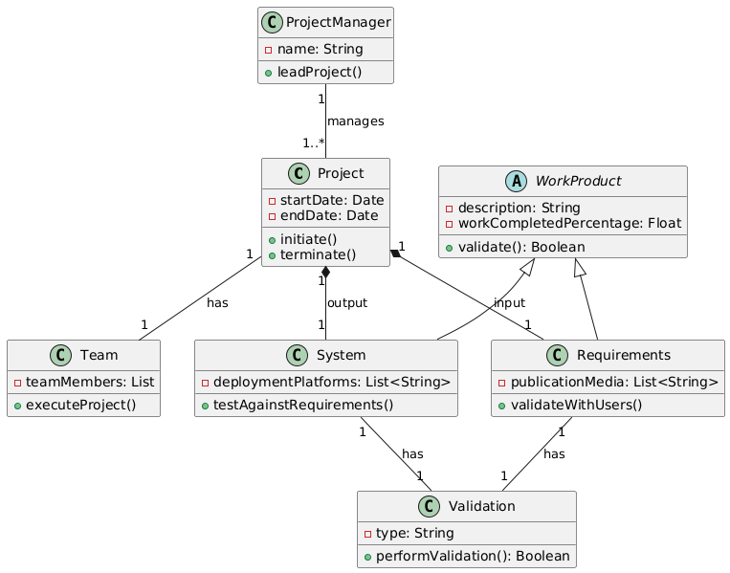

Syntatic
Semantic:
- Incorrect cardinality in the relationship between requirements and project should be 1…* - “a project uses requirements”
- The use of composition in the relationship Project with Requirements and System indicate a strong dependency
- The use of cardinality of “1” for associations from Requirements and System to the Validation class contrudic the system requirements that says that “may be validated”
- Missing relationship of leadership between project manager and team “the project manager leads a team”
Pragmatic:
- Inconsistency and redundancy in validation mechanisms. Has a operation in the abstract class WorkProduct and specialized validation methods in its subclasses (validateWithUsers and testAgainstRequirements), and a mandatory one-to-one association with a separate Validation class, which confuses the intended validation workflow.
- PublicationMedia and deploymentPlataforms use List<String>, but the attribute teamMembers is left as just List
- The indirect representation of the project manager’s leadership (through Project's association to Team) diminishes clarity regarding the explicit leadership role the project manager should have over the team.
Deepsheek
Syntatic:
- Missing the enum for ProjectStatus, we don’t know to what it corresponds to.
Semantic:
- Missing the relationship between team and project manager, “the project manager leads a team”.
- The use of relationship “validated by” is incorrect, the requirements don’t validate the system. “requirements are validated with users in workshops, and the system is validated by being tested against the requirements.”
Pragmatic:
- Both ProjectManager and Project contain initiation and termination operations
- The explicit implementation of the Validation interface alongside the inherited validate() operation introduces confusion and ambiguity

